Daniel W. Wolf
Computer Organization
Final Project Write Up

SCORE
Basic Processor | 70
Control Logic | 5
16 bit | 5
Beq | 10
Jump | 10
Total | 100

Proof:

BASIC PROCESSOR:

The proof for the basic processor is in the pictures that are contained in the Basic folder. There was a weird error at the end where the hex values I loaded into instruction memory were not being loaded correctly, however I did not have time to fix it.

CONTROL LOGIC:

Originally I implemented the control logic as just a basic circuit that took in the opcode and sent outputs to the correct places. With Ryan Muthers suggestion I changed my implementation in order to utilize ROM. This allows my opcode to act as the address to a place in the ROM's memory. This significantly reduces the size of my opcode. I did not decrease the size of my opcode from 5 bits so that the design could be built upon and more instructions could be added. A picture of my implementation can be found just below this section. If I had to talk about a flaw in my design I would say that I would want a full 0 opcode to be a null op, but it is instead an addition operation. However, due to the design of the control logic it can be easily changed.

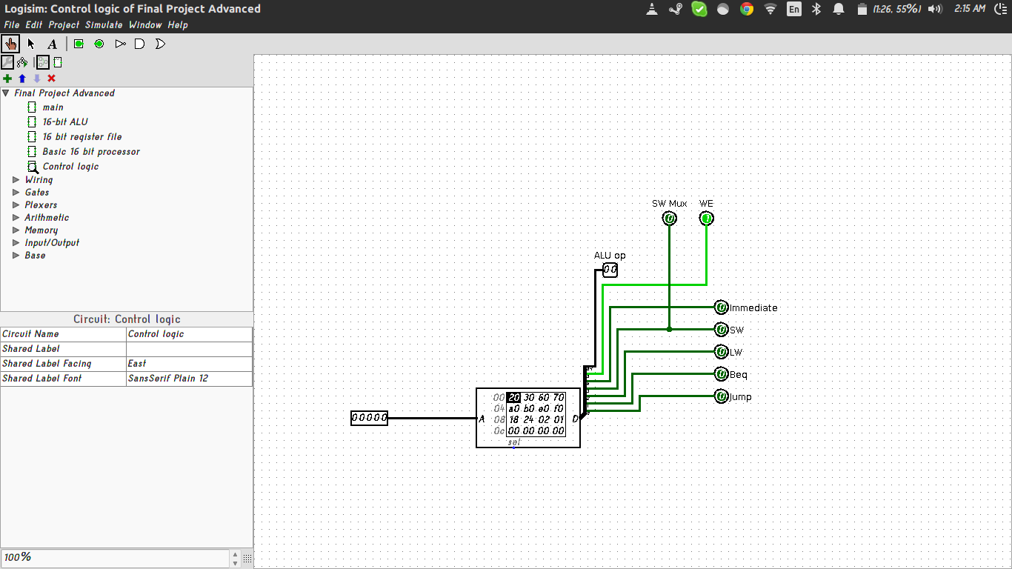

16-BIT:

Implementing this was mostly a matter of changing most of the components to accept 16 bit input and output. It can hold 16 bits per register in the register file.
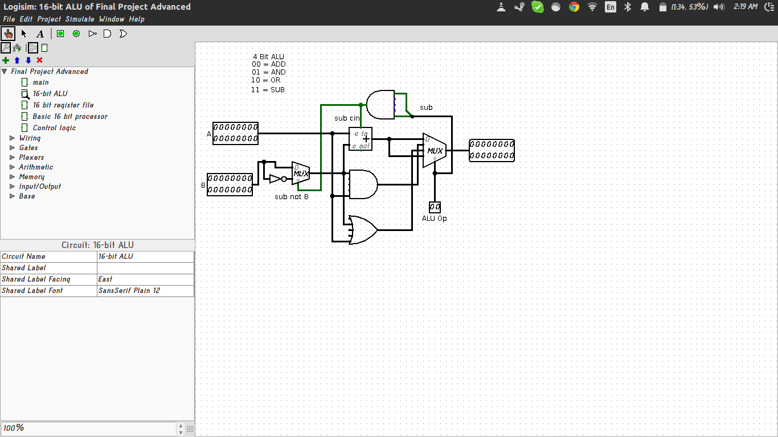
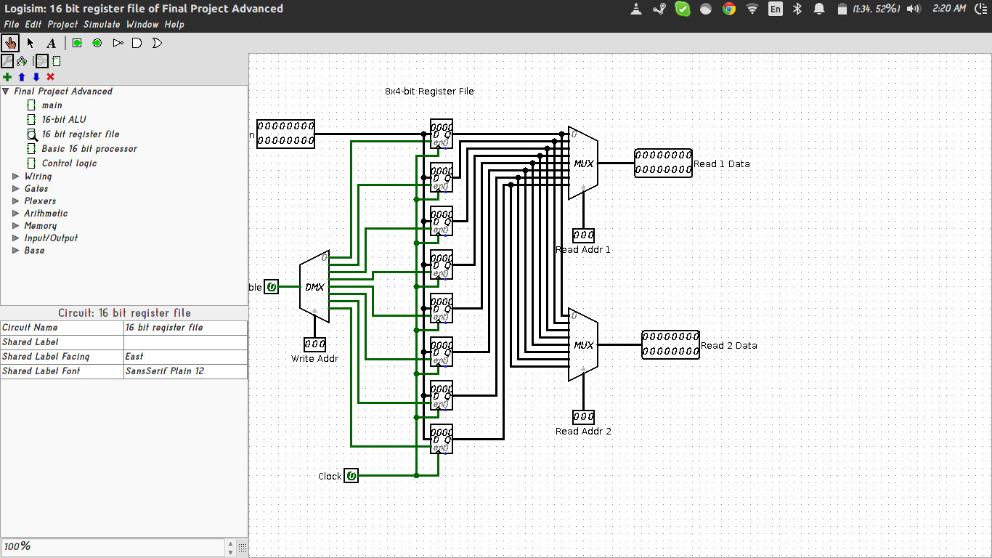

BRANCH IF EQUAL:

This was one of the more challenging things to implement. To do this I used a comparator to test the values of the first 2 registers fed to it and then used the immediate as how far to branch. In order to stop it from writing an addition operation to a register I made sure Write Enable was at 0.

JUMP:

In order to implement jump I set Write Enable to 0 and took the 3 register addresses as one big immediate. This let me move anywhere in my 9 bit addressed instruction memory.
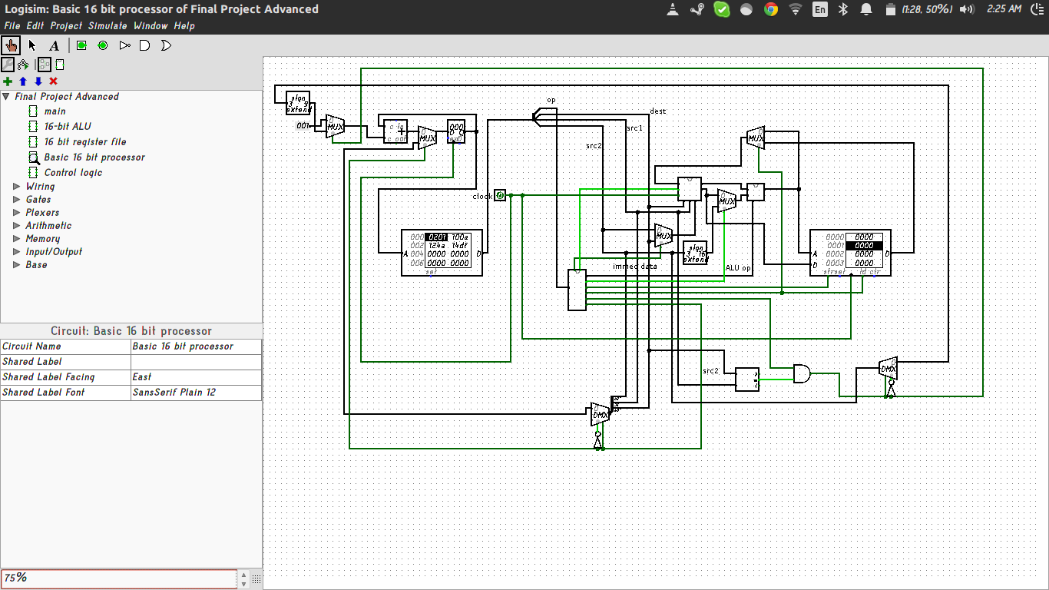

If you would like to test it using assembly code you can use the file called beqAndJump.txt. If you run it through my python program you will get a hex file that you can use to test more thoroughly.

DESIGN DECISIONS:

There were a lot of decisions I had to make along the way. One major one was how I was going to implement my control logic in order to allow for branch and jump instructions. I had a 5 bit instruction word that wasn't big enough to deal with every different type of instruction I wanted. After talking with Ryan Muther I decided I would try something similar to how he implemented his control logic. This control logic design allows me to have almost double the amount of possible instructions. Another design decision that I made was the 8 register register file. I was originally going to have 16 register files to allow for more registers, however I found that I was barely using 6 of the 8 registers and so the idea was scrapped. I also decided to make my language very minimalistic and only use registers labeled 's'. This was more of a personal aesthetic decision and didn't have any noticeable drawbacks.

MACHINE CODE:

The machine code for each instruction is found in the following dictionary. All of the I type instructions take immediate arguments and the jump instruction just takes a number which is the index of instruction to jump to.

add:00000, and:00010, or:00100, sub:00110, addi:00001, andi:00011,
ori:00100, subi:00111, beq:01010, jump:01011, s0:000, s1:001, s2:010, s3:011,
s4:100, s5:101, s6:110, s7:111, lw:01001, sw:01000

the opcode is 5 bits and each register is 3.

NOTES ON THE ASSEMBLY:

the format of the actual assembly code is very minimalistic and easy to use. You are given registers which all start with the letter 's' and go from 's0' to 's7'. There are the basic 'and', 'add', 'or' and 'sub' operations. In addition to those there are the 'load word' and 'store word' operations which are denoted as 'lw' and 'sw' respectively. Branch if Equals, denoted as 'beq' lets you jump to any instruction as long as it is within 3 bits of instruction memory away. Finally, there are 'jump' instructions which take a 9 bit immediate number for the address in instruction memory to jump to.

The format is as follows:(examples)

add s1 s0 s2

addi s2 s3 s4

jump 17

beq s1 s1 -3

HOW TO CONVERT ASSEMBLY INTO HEX:

I have written a small python program that takes assembly code and translates it into hex. As of now you will have to run it and call the function 'assemble'. This function takes a filename as its argument and then creates a new file called newHexFile.hex. This hex file contains the contents of the text file converted into hexadecimal values.

WARNING:

The python program does not allow for comments at this time, if there are lines that do not conform with the syntax of the assembly language as outlined above it will not work. I have added a clause that prints out the line that it errors on so that you can debug more effectively.

